**Box Plot Application**

**User’s Guide**

Emilia Gan

10 June 2016

**1 Introduction**

This application uses the R package Shiny (ref**) to create a graphical user interface with which a user can upload a data file and create box plots of selected genes to view and analyze variability in the expression of these genes across multiple samples. In addition to providing the capability of R to perform this task to users who are not familiar with the R programming language, the application has the further advantage of providing a level of flexibility beyond the typical R script. Specifically, the ease with which genes can be selected and deselected by simple mouse clicks and the ease with which new data files can be loaded, make analysis using the Shiny application more efficient even for expert R programmers.

**2 Setting Up Your R Environment**

*2.1 Installation of R, RStudio, and Required R Packages*

In order to run this application locally, you will need to have the free R software environment and the open-source RStudio integrated development environment (IDE) installed. Downloads for R are available for Unix platforms, Windows, and Mac OS. Installation instructions for each of these can be found using the following links:

* The R Project for Statistical Computing: <https://www.r-project.org/>
* RStudio IDE: <https://www.rstudio.com/>

Once you have this software installed, you need to install the following R packages:

* *shiny*: Web application framework for R
* *edgeR*; Empirical analysis of digital gene expression data in R
* *ggplot2*: An implementation of the grammar of graphics
* *limma*: Linear models (for all gene expression technologies)

Installing R packages from within the RStudio IDE is quite straightforward:

1) Open the RStudio IDE.

2) Click on the “Packages” tab to see a listing of currently installed packages.

3) All of the packages required to run the Box Plot Application are in the Comprehensive R Archive Network (CRAN) repository. Accordingly, they can be easily installed from within the RStudio IDE by following this sequence:

a) Click on the “Install” tab. A pop-up window will appear.

b) Type in the name of the package you wish to install.

c) Check the box labeled “install dependencies” to ensure that any packages required by the package you are requesting are automatically installed as well.

A screenshot illustrating the package installation process is provided below:

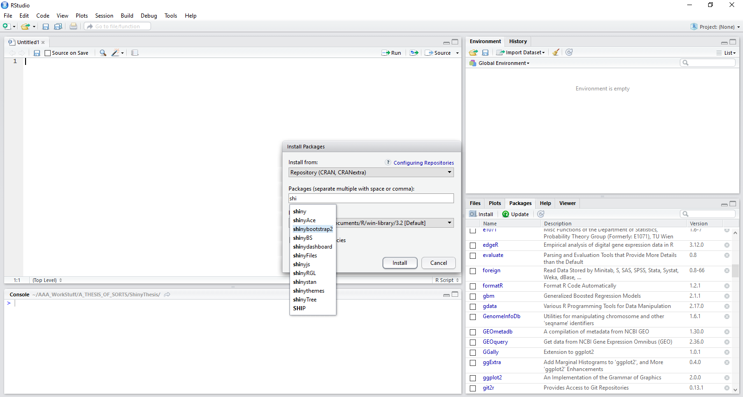

**Figure 1:** Installing R packages within the RStudio IDE.

*2.2 Downloading the Box Plot Application Files*

All R code files needed to run the Box Plot Application are publically available online on GitHub. The work is shared under an MIT License, meaning that it may be used without limitations, provided attribution is given to the author and the author is released from any liability relating to use of the code.

Once downloaded, the application files may be stored anywhere in your local file system. For the applications to work most efficiently, the downloaded files for the Box Plot Application should be kept together in a single folder. R requires that each Shiny application be names “app.R” in order to be recognized and run as an application, without the code needing to be manually selected and highlighted. In addition, files that contain material the Shiny application needs to access, such as local image files, need to be stored in a folder named “www.” Keeping each app.R file and its associated www folder in its own, informatively named directory makes organizing this, and other, Shiny applications possible. The file hierarchical diagram shown below illustrates one option for organizing Shiny application files.

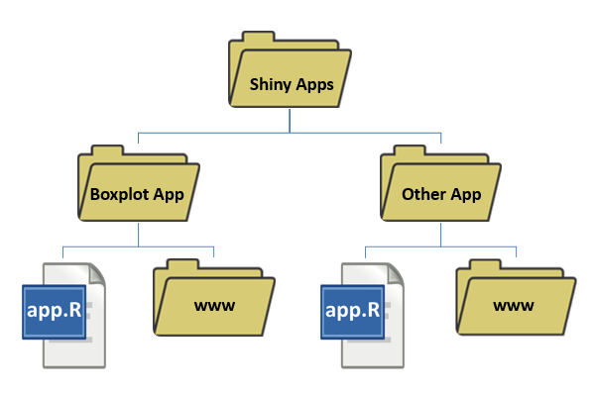

**Figure 2:** File organization for Shiny applications.

*2.3 Running the Box Plot Application*

Once the R environment has been set up, the Box Plot Application can be run from within R Studio. To do this, open RStudio and open the Box Plot Application’s “app.R” file. After the code has opened in RStudio, the application can be deployed by clicking the “Run app” button as illustrated in the screen shot provided in Figure 3. Once the application has deployed, its functionality is accessed exclusively through the graphical user interface (GUI).

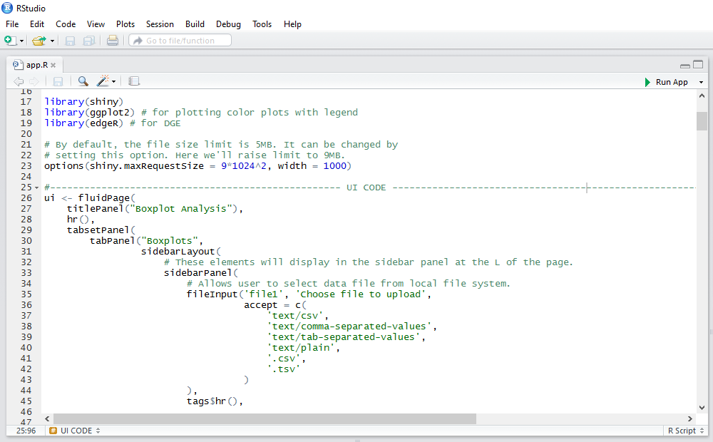

**Figure 3:** Deploying the Box Plot Application

Open the Box Plot Application’s app.R file in RStudio, then deploy the application from within RStudio by clicking the “Run App” arrow in the top right corner (outlined in red).

**3 Overview of features**

*3.1 Box Plot Application Layout*

Upon launching the Box Plot Application, the GUI opens. Figure 4 points out the various features of the Box Plot Application layout.

A. File upload box that allows the user to select an appropriately formatted file to upload from any location in the local file system.

B. Radio buttons to provide information on the file type to the application.

C. Radio buttons to provide information to the application on how the data are arranged in the data file.

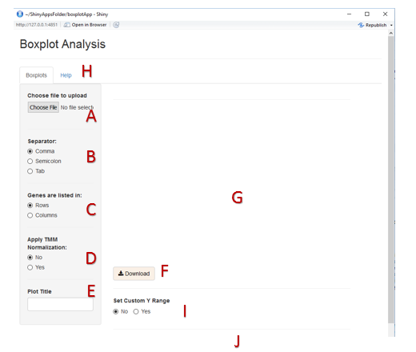

**Figure 4:** Box Plot Application Layout

D. Radio buttons to enable the user to indicate whether or not TMM normalization should be applied to the data. TMM normalization is discussed in Section 3.6 of this document.

E. Text entry box that allows the user to input a title for the plot(s) created.

F. Download button to save the plot created as a .pdf file.

G. Main plot display area.

H. Tab to a “Help” page that describes the format required of the data files uploaded to the application.

I. Radio buttons that allow the user to generate a second copy of the plot with a customized y-axis range. Selecting “Yes” in this set of radio buttons will cause a slider input to appear to the right of the radio buttons, along with a duplicate plot below (as displayed in Figures 5).

J. Area where data file itself will be displayed in tabular form.

*3.2 Uploading Files and Selecting Features for Plotting*

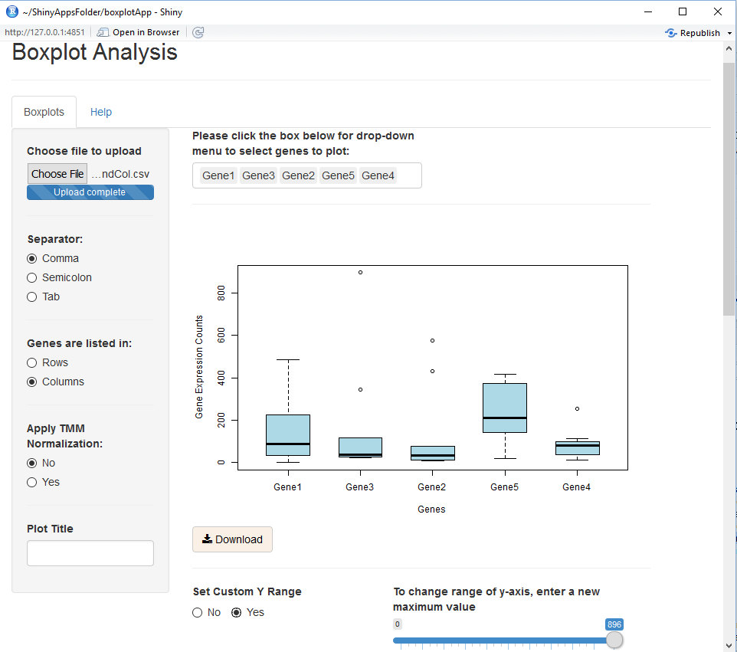Upon uploading an appropriately formatted file, a data entry box appears. When this box is clicked, a drop down menu will appear with a list of the features (typically genes) to use in creating the plot. This is shown in Figure 5.

**Figure 5:** Box Plot Application with Uploaded Data File and Generated Plot.

The plot is generated once the first feature is selected. As additional features are selected for plotting, the plot dynamically updates itself. Features may be removed from the plot by selecting them in the data entry box and pushing the “Backspace” key or the “Delete” key on the keyboard. Additional features may be added at any time by selecting them from the drop down menu. A title may be entered via the text entry box labeled “Plot Title” in the sidebar panel. As mentioned, clicking inside the data entry box causes the drop down menu to appear. Clicking outside the box causes the drop down menu to close. At the same time that a data file is uploaded, the data in the data file are displayed at the bottom of the application in tabular format, as shown in Figure 8.

To select a new data file, all that is required is to return to the file upload box and select a new file from the local file system.

*3.3 Permitted File Formats*

The Box Plot Application can accept files in comma-separated value format (.csv or .txt), tab-separated value format (.tsv or .txt), or in semicolon-separated value format (.txt). The file should have both column names and row names for the data. In addition, the file may contain optional type information, if the elements (typically samples being sequences and genes) belong in different categories. While this data is not used by the Box Plot Application, it is used by its “partner” application, the Principal Component Analysis Application. The same data file can thus be used with both Shiny Applications.

The formatting of the data file is critical to the proper operation of the Box Plot Application. Figure 6 provides an example of the format that should be followed when preparing data for use with the application.

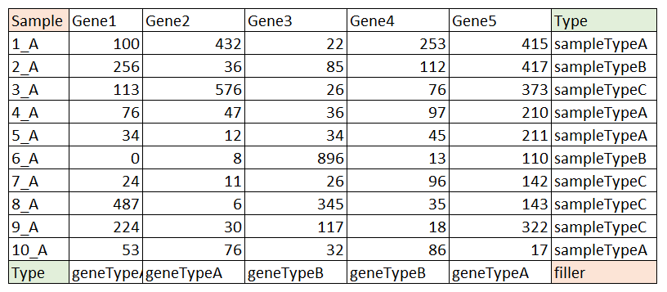

**Figure 6:** Proper Formatting of Data

There must be text in the top-left and bottom-right cells. However, the actual words “Sample” and “filler” are not critical and may be changed. Including type data is optional, but if it is included for either samples or genes, the word “Type” is critical, as the data will not be processed appropriately if this keyword is missing.

Figure 6 displays a data file as it might appear in a program such as Excel, before being converted to a comma-separated value file, or other permitted file format. All data files are required to include both column names and row names. For the use the application was designed for, these names will identify both the samples and genes included in the data set. The cells highlighted in red MUST contain text, as the data file is not permitted to contain any empty cells, but the actual word chosen is not critical. Type (or categorizing) information is optional. However, when such data are included, the word “Type” must be used in the cells highlighted in green in Figure 6. Keeping this format in mind, the red-highlighted cell in the lower-right corner is only an issue when BOTH row elements and column elements have associated type data. Figure 7 displays thumbnail versions of each of the permitted formats.

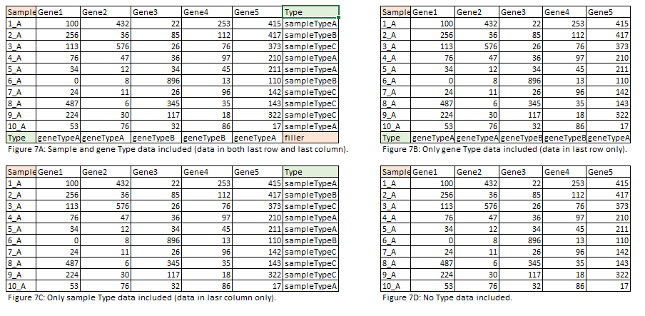**Figure 7:** Permitted file formats

Examples of permitted file formats illustrating, once again, that column names and row names are required (first column and first row and that type (categorical) information is optional, but, if present, must be identified using the keyword “Type.”

*3.4 Rescaling the y-axis*

Due to potentially wide variation in the expression levels of genes, certain box plots may appear excessively “compressed.” Accordingly, the user is given the ability to change the range of the y-axis at will by clicking on the “Yes” option of the “Set Custom Y Range” radio buttons. Changing this setting to “Yes” causes a slider input widget to be displayed. In addition, once the slider has been clicked, its position may also be controlled via the right and left arrow keys on the keyboard. The slider input and its effect on the y-axis range are illustrated in Figure 8.

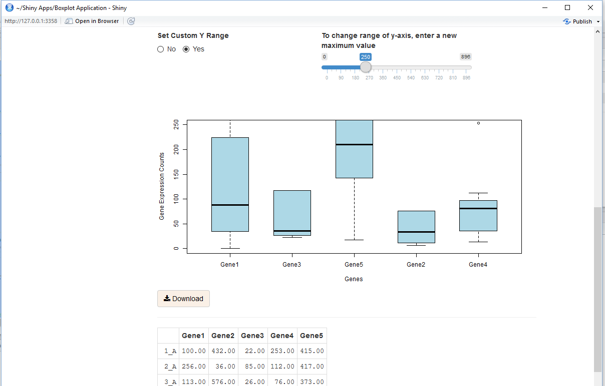

**Figure 8:** Rescaling the y-axis

The y-axis range is controlled by the slider input widget that appears on the screen once the “Set Custom Y Range” radio buttons are set to “Yes.” Note the presence of the top portion of the data file in tabular form under the scaled plot.

The rescaled (lower) plot will have the same plot title as the initial (upper) plot, or no title if no text was entered in the text entry box labeled “Plot Title” in the sidebar panel.

*3.5 Interpreting the Box Plots*

The box is a graphical representation of a data set. The various sections of the box plot represent different values. The top, middle, and bottom lines of the plot represent the 3rd, 2nd, and 1st quartiles, respectively. The “whiskers” represent the highest and lowest data values that fall within 1.5 IQR of the 3rd quartile and 1st quartile, respectively. Outlier are represented by points in line with, but falling above or below the ends of, the whiskers.

This application was designed to create box plots of gene expression counts data across multiple samples. Selecting more genes from the drop down menu will result in a plot with correspondingly more aligned box plots. The plots created by the Box Plot Application can contain between 12 and 18 box plots before the box plots become so cramped as to be difficult to interpret.

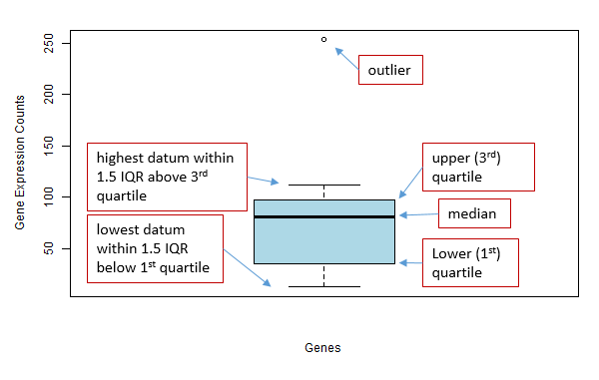

**Figure 9:** The Box Plot

The box plot, also known as a box-and-whisker plot, graphically depicts sets of numerical data.

*3.6 Trimmed Mean of M-values Normalization*

Normalizing the RNA-Sequencing counts data is a standard step in the data analysis pipeline. However, there is no consensus on the “best” normalization method to use, and a number of different methods are commonly used. The PCA Application offers the option of normalizing the uploaded data using the Trimmed Mean of M-values (TMM) method described in the article by Robinson and Oshlack (6).

The TMM normalization method uses raw counts data to estimate scaling factors to ensure that genes being expressed at the same level in different samples are not erroneously flagged as being differentially expressed. The base assumption of the method is that the majority of genes are not differentially expressed. The method estimates the ratio of RNA production between samples by calculating a weighted trimmed mean of log expression ratios. The PCA Application uses the default setting in the edgeR package for the percentage of data trimmed before the mean calculation.

In acknowledgement of the existence of other normalization techniques and the possibility that the user of the application may wish to use some method other than TMM, whether or not the data being plotted undergo the normalization or not is user-controlled via the “Apply TMM Normalization” set of radio buttons. The user thus has the option of conducting the normalization step prior to uploading the data file for plotting, or bypassing this step altogether to look at raw counts data.

*3.7 Downloading Plots*

The plots generated by the Box Plot Application may be saved to the local file system as .pdf files by clicking on the “Download” button located under each plot.

**4 Troubleshooting and How to Get Help**

All attempts have been made to thoroughly test this application. Should features fail to work as described, the most common source of the problem is likely to be an improperly formatted data file. Please refer to the diagrams showing accepted formats.

It is also important to click the appropriate radio button for the file format being uploaded. The app will not process a comma-separated value file, for example, despite its being a permitted format, if the radio button clicked indicates that it should be uploaded a tab-separated values file.

This software is being made publicly available for all uses, including modification. It is thus offered with no guarantees or support provided. However, the software author may be contacted at [efgan@uw.edu](mailto:efgan@uw.edu), and will provide assistance when possible.

**5 References**

1. R Core Team (2015). R: A language and environment for statistical computing. R Foundation for Statistical Computing, Vienna, Austria. URL <https://www.R-project.org/>.

2. RStudio Team (2015). RStudio: Integrated Development for R. RStudio, Inc., Boston, MA URL <http://www.rstudio.com/>.

3. Institute for Statistics and Math (Wirtschaftsuniversitat Wien). The Comprehensive R Archive Network, <https://cran.r-project.org/> , accessed 8 May 2016.

4. The Open Source Initiative. The MIT License (MIT), <https://opensource.org/licenses/MIT> , accessed 8 May 2016.

5. Robinson, Mark D and Alicia Oshlack. “A scaling normalization method for differential expression analysis of RNA-seq data.” *Genome Biology* (2010), 11:R225.

6. Robinson MD, McCarthy DJ and Smyth GK (2010). edgeR: a Bioconductor package for differential expression analysis of digital gene expression data. Bioinformatics 26, 139-140